**2403a51238**

**Chandana**

**Batch:11**

**AI-ASSISTED-CODING**

**Assignment-8.1**

**Task Description #1** (Password Strength Validator – Apply AI in Security Context)  
• Task: Apply AI to generate at least 3 assert test cases for is_strong_password(password) and implement the validator function.  
• Requirements:  
1) Password must have at least 8 characters.  
2) Must include uppercase, lowercase, digit, and special  
character.  
3)Must not contain spaces.

**Prompt:** Generate at least 3 assert test cases for is_strong_password(password) and implement the validator function.

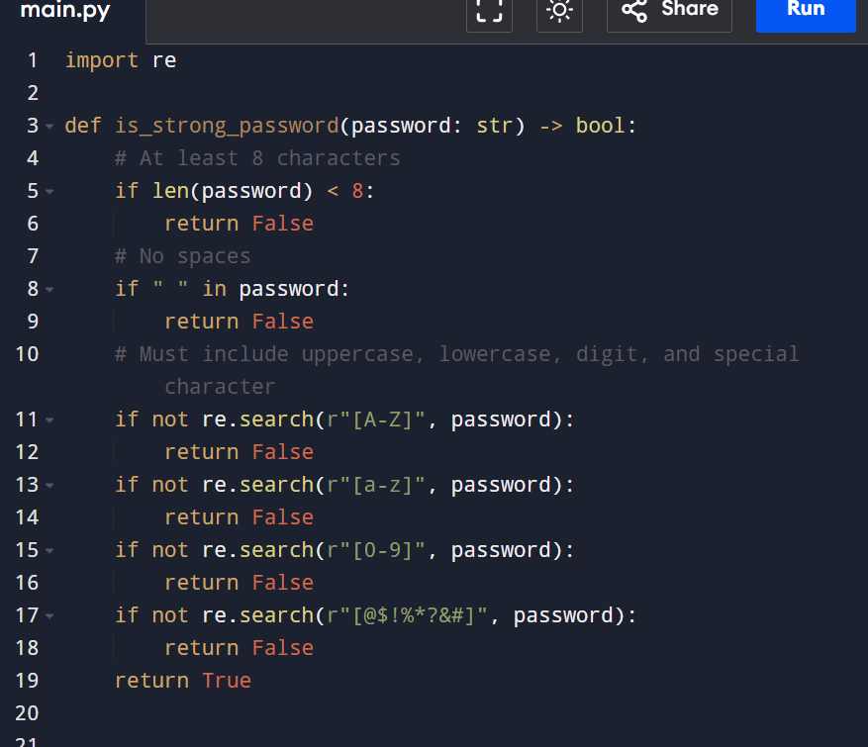

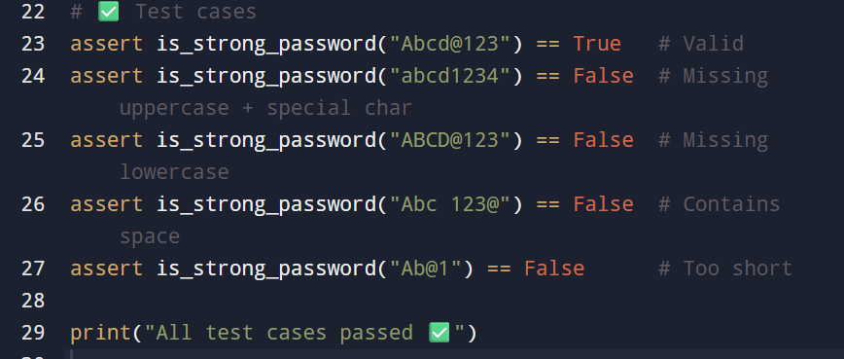

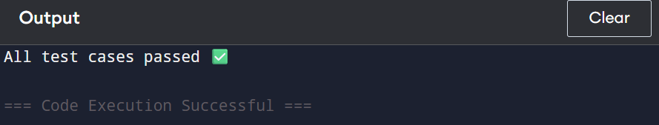

**Task Description #2** (Number Classification with Loops – Apply AI for Edge Case Handling)  
• Task: Use AI to generate at least 3 assert test cases for a classify_number(n) function. Implement using loops.  
• Requirements:  
=> Classify numbers as Positive, Negative, or Zero.  
=>Handle invalid inputs like strings and None.

=> Include boundary conditions (-1, 0, 1).

**Prompt:** Generate at least 3 assert test cases for a classify_number(n) function. Implement using loops.

**Example Assert Test Cases:**  
assert classify_number(10) == "Positive"  
assert classify_number(-5) == "Negative"  
assert classify_number(0) == "Zero"

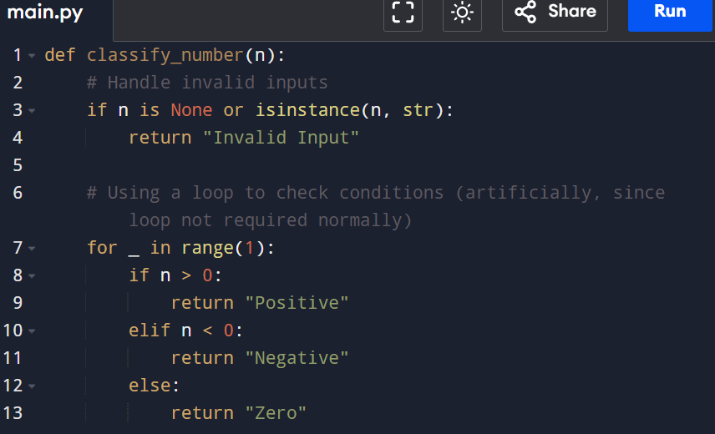

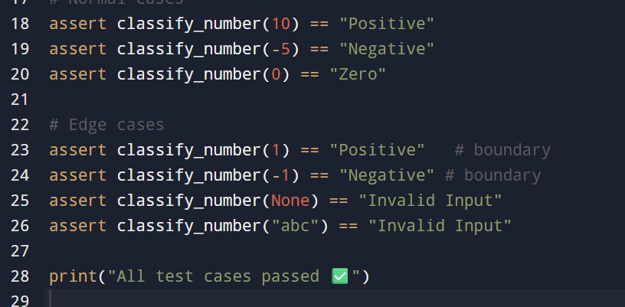

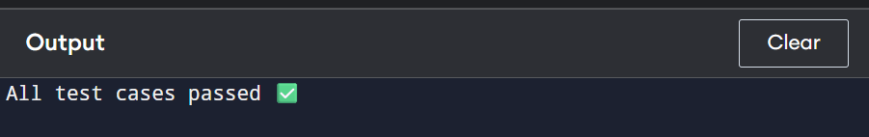

**Task Description #3** (Anagram Checker – Apply AI for String Analysis)  
• Task: Use AI to generate at least 3 assert test cases for is_anagram(str1, str2) and implement the function.  
• Requirements:  
=>Ignore case, spaces, and punctuation.  
=> Handle edge cases (empty strings, identical words).

**Prompt:** Generate at least 3 assert test cases for is_anagram(str1, str2) and implement the function.  
**Example Assert Test Cases:**  
assert is_anagram("listen", "silent") == True  
assert is_anagram("hello", "world") == False  
assert is_anagram("Dormitory", "Dirty Room") == True

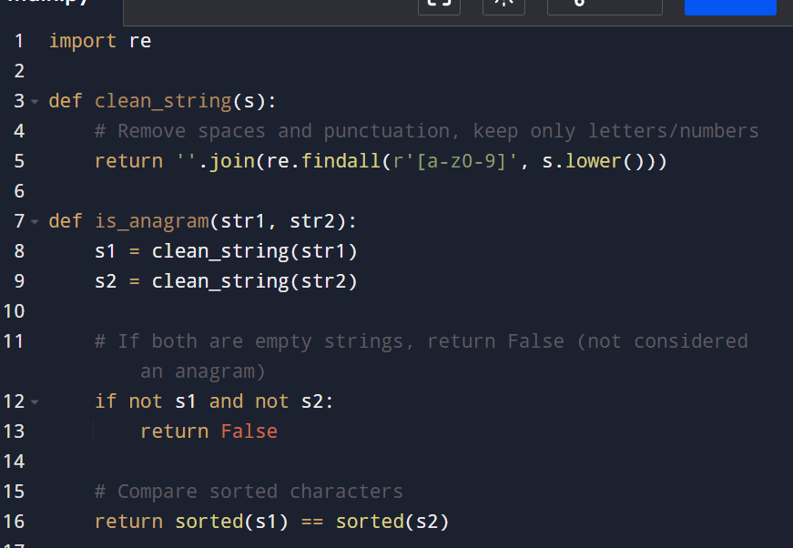

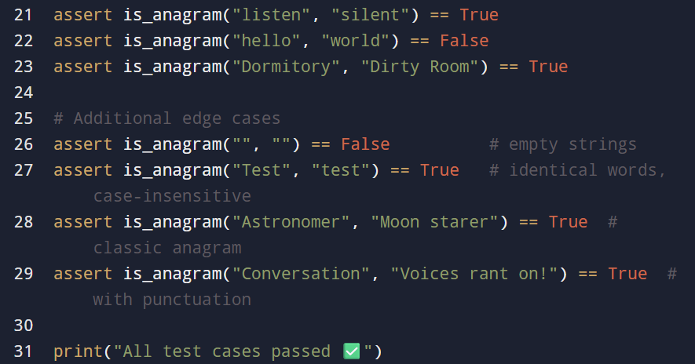

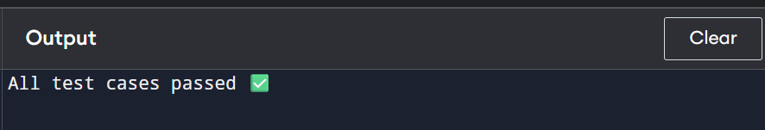

**Task Description #4** (Inventory Class – Apply AI to Simulate Real- World Inventory System)  
• Task: Ask AI to generate at least 3 assert-based tests for an Inventory class with stock management.  
• Methods:  
=> add_item(name, quantity)  
=> remove_item(name, quantity)  
=> get_stock(name)

**Prompt:**Generate at least 3 assert-based tests for an Inventory class with stock management.  
**Example Assert Test Cases:**inv = Inventory()  
inv.add_item("Pen", 10)  
assert inv.get_stock("Pen") == 10  
inv.remove_item("Pen", 5)  
assert inv.get_stock("Pen") == 5  
inv.add_item("Book", 3)  
assert inv.get_stock("Book") == 3

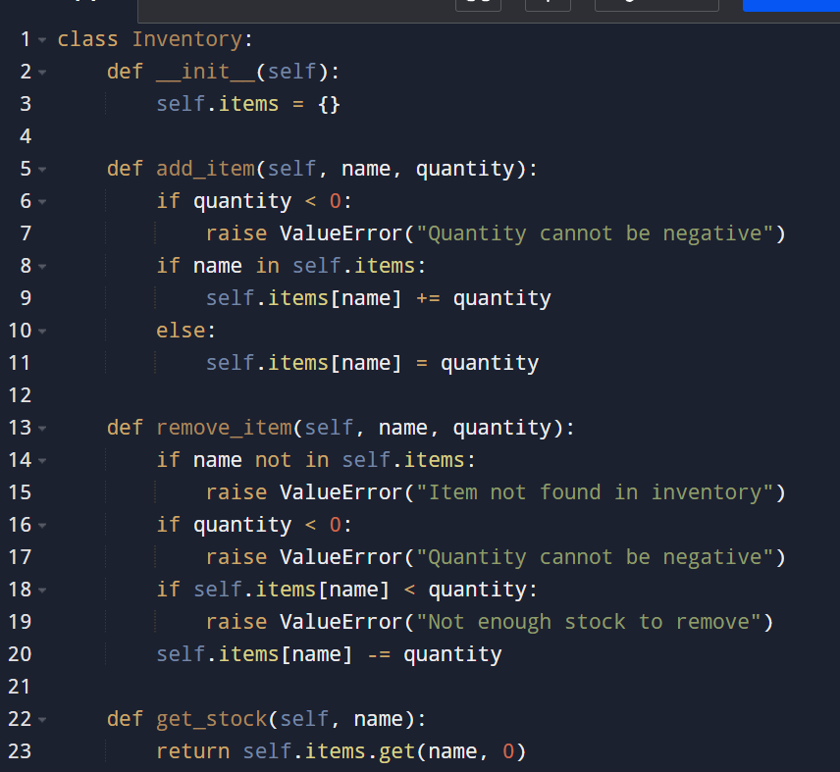

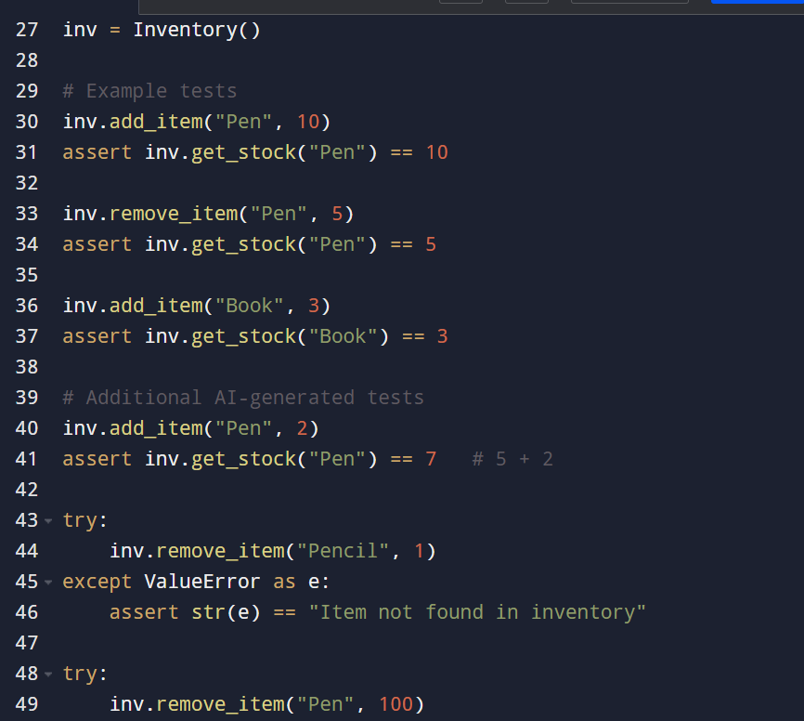

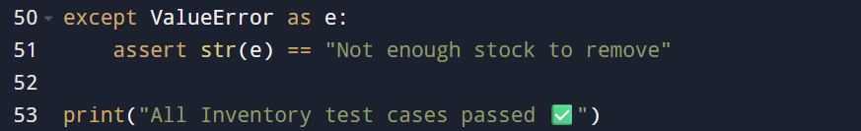

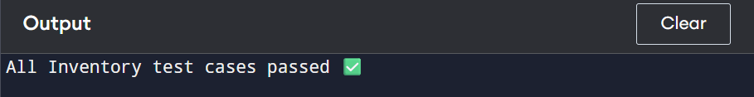

**Task Description #5** (Date Validation & Formatting – Apply AI for Data Validation)  
• Task: Use AI to generate at least 3 assert test cases for validate_and_format_date(date_str) to check and convert dates.  
• Requirements:  
=>Validate "MM/DD/YYYY" format.  
=> Handle invalid dates.  
=> Convert valid dates to "YYYY-MM-DD".

**Prompt:**Generate at least 3 assert test cases for validate_and_format_date(date_str) to check and convert dates.

**Example Assert Test Cases:**assert validate_and_format_date("10/15/2023") == "2023-10-15"  
assert validate_and_format_date("02/30/2023") == "Invalid Date"  
assert validate_and_format_date("01/01/2024") == "2024-01-01"  
 